Dear AMS Member,

Please find the latest news and announcements from the Society below.

Stay safe & stay well.

Regards,

Leona Campbell
President, Australasian Mycological Society

2020 Annual General Meeting – Wednesday August 19th at 11 AM AEST
The AGM will be held on August 19th at 11 AM AEST. It will be held electronically via Zoom. As a reminder, a notification email will be circulated in the weeks preceding the meeting. To attend, simply contact AMS secretary Laszlo Irinyi (geza25@hotmail.com) for a Zoom invitation. A nomination form for council positions is attached here. Nominations must be sent to the secretary by August 5th, 2020. Agenda items can also be sent to Laszlo and a final outline of the meeting agenda will be circulated to attendees prior to the AGM.
Please note, all our current council members have served for a number of years and I would like to thank them for their dedication to the society. This year myself as President, and Jeff Powell our Vice President, have served our maximum 3 years and will be stepping down from our positions. We would like to invite all members, but especially our ECRs to consider joining the council. If you are considering nominating for a position and would like more information about the requirements of each council role, please contact me (leona.campbell@sydney.edu.au).

Changes to legislation that prescribes the operation of incorporated associations
Last year new rules for Incorporated Associations were introduced by the federal government. The Red Tape Reduction Legislation Amendment Bill 2018 made amendments to the Act and the Regulations affecting incorporated associations. These new rules will require minor changes to be made to the Society’s Constitution. The wording of these changes will be proposed for members to ratify at the 2020 AGM. A summary of the changes to be addressed are listed below;
An association member can now request meeting minutes from the association
General members of an association can request copies of a variety of documents relating to the association. In our Society, members have always been welcome to request documents, however this change will formalise the ability of members to easily access and source information.
Procedures for disputes to be adopted
An association must have a dispute resolution procedure (covering disputes between two members, or between a member and the association). This assists members and the committee to resolve or determine solutions for disputes. For this, we will be referring to the relevant section in the Act, “Part 4, Section 65B, Dispute resolution procedure”.
The association’s register of members
The requirements for a register of members has been simplified. A register of members must now contain information about a person, their name and contact details, the class of their membership, the date the person became a member of the association or anything else required by the association’s rules of regulation. While the register must contain the above particulars, a member of the association may request that the committee restrict access to the member’s personal information. For this, we will be referring to the relevant section in the Act, “Part 2, Section 13A, Contact details may be kept confidential”.
For more information about the relevant sections, visit: https://www.legislation.act.gov.au/a/1991-46/

Congratulations to our 2020 AMS Research Award recipients
Congratulations to our 2020 AMS Research Award recipients (Note: due to the COVID-19 crisis, there will be no Travel Grants awarded this year. Therefore, the executive committee approved the awarding of three Research Awards for 2020);
- Elaine Davison, Research Associate, Curtin University, Project title: “Amanita umbrinella and its relatives”.
- Leanne Greenwood, PhD Candidate, Charles Sturt University. Project title: “How does fire effect arid fungal communities?”
- Rebecca Jane Webb, PhD candidate, James Cook University. Project title: “Glutathione biosynthesis in the amphibian fungus, Batrachochytrium dendrobatidis”.

All applications received by the review committee were of a very high quality and we would like to thank everyone who submitted an application, both for the time you put into preparing it and your continued support of the Society.

Online Mycology talks and meetings
A reminder that we have added a new section onto the Society website to promote mycology eTalks and eMeetings – see https://www.australasianmycologicalsociety.com/other-mycology-meetings
If you would like to advertise a mycology eTalk or eMeeting to the membership via this webpage please contact our webmaster Dee Carter dee.carter@sydney.edu.au

Australian Taxonomy Community Directory
One of the recommendations from the Taxonomy Australia meeting earlier this year about the All Species Mission was to create improved networks among taxonomists. To this end, Taxonomy Australia has introduced the Australian Taxonomy Community Directory. All involved in taxonomy are welcome on the Directory, including employed and actively retired researchers, collections and technical staff, specialist collectors and students. To add your details, go to https://www.taxonomyaustralia.org.au/tcd-search and click the Join Here link and proceed to the log in page. If you have not already signed up on the Taxonomy Australia website, please sign in at this stage using the Sign Up link (signing up for the Taxonomy Australia website is easy and quick), otherwise log in. The Directory will have many uses, including providing stakeholders and others with a way to find expertise and skills within the taxonomy community, providing the community itself with a way to find and share skills with others, and providing community members with a way to become aware of and contact other community members who have shared interests, skills, taxonomic groups, field work needs etc.

Conservation Coordinator – Plants and Fungi, Global Center for Species Survival
Applications are being accepted (closing 1 August) for a new position of Conservation Coordinator- Plants and Fungi at the Global Center for Species Survival (GCSS). The Global Center for Species Survival (GCSS) has been established as a partnership between the Indianapolis Zoo and the IUCN Species Survival Commission (IUCN SSC). The Conservation Coordinator – Plants and Fungi is one of 7 Conservation Coordinators (each assigned to a specific Group). The Coordinator will be part of a multicultural team of full-time staff employed by the Zoo dedicated to support the missions of the Indianapolis Zoo and the SSC. The GCSS Staff Team will provide critical training, capacity and coordination support to further mobilize the species conservation efforts of IUCN SSC Network of experts alongside wider partner and key stakeholder communities. The Conservation Coordinator -- Plants and Fungi will support the programs of the SSC’s plant and fungi Specialist Groups. These Groups are focused on assessing, planning and mobilizing policy and action for plant and fungi species conservation around the world. GCSS positions are open and available to all candidates worldwide. International candidates must be able to acquire a work visa. Fluency in English a requirement of all positions. Fluency in other languages is desired. For more information go to: https://www.indianapoliszoo.com/jobs-volunteer/available-positions/conservation-coordinator-plants-fungi/

Expressions of interest
In the past months, we have had a few contacts from commercial entities looking for mycologist partners. See below;

Calling any and all North Queensland based Mycology experts and enthusiasts to join with us to create a new business venture to grow the first commercial biocomposite made from local waste. We need a dedicated team of passionate mycelium growers to create a plant in Townsville, in partnership with us, <1.5º design.

For more information contact Sara Cole saracole@urbanmoments.org
Check out our green architecture www.urbanmoments.org
Product example + license https://ecovativedesign.com/mycocomposite

Calling on a Material Revolutionist to join a collaborative research and development team based in Sydney. This field research and development is in bio-manufacturing, exploring mycelium as a medium for growing ethical materials for construction and product design out of agricultural waste.

Driven by the need for innovation based on regenerative practises, inspires the idea of revolutionising the built environment. Our strategy is centred in biomimicry, nature inspired design that allows us to learn from and mimic the strategies found in nature to solve complex human design challenges.

We consider waste as a human idea - we connect waste with purpose by the mycoremediation of the industrial ecology. Tapping into the queendom of fungi, we are able to restore unwanted materials into products of responsibility and efficiency.

What you will be doing:
• Research and develop Mycelium strains for biomaterials
• Train mycelium strains in developing biomaterial prototypes
• Continue to develop and test biomaterial prototypes

What we need from you:
• Alignment in vision and philosophy
• Charisma, uniqueness, creativity, and tenacity
• Experienced mycologist - growing mycelium on various substrates
• Willing to learn, educate and grow with us

See the attached PDF for more details.

We want you to join (y)our revolution!
More information and applications please contact Daniel on the details below.
Email: goldy059@gmail.com
Mobile: 0406738522

Fungi Portrait, Purple pouch fungi in New Zealand
In New Zealand, sequestrate species are common in genera otherwise comprising agaricoid species. The sequestrate species have a convoluted hymenium that remains enclosed by the pileus at maturity. They are often brightly coloured and are colloquially known as pouch fungi. Andy Nilsen and colleagues investigated the diversity of purple pouch fungi in the genus Cortinarius in New Zealand, using molecular markers, and detected seven species in a number of different lineages within Cortinarius – including four new species. An existing species, Cortinarius porphyroideus(based on Secotium porphyreum) was described in 1924. Given the subtle morphological differences between the seven species of purple pouch fungi, it was important to link modern sequenced collections back to the type. This was achieved by a genome skimming approach that retrieved ITS and 28S sequences from the nearly 100-year old type specimen. Several of the purple pouch fungi are widespread in native forests in New Zealand, but Cortinariusporphyroideus remains known only from three closely located sites in the Wellington region.

Nilsen AR, Wang XY, Soop K, Cooper JA, Ridley GS, Wallace M, Summerfield TC, Brown CM, Orlovich DA (2020) Purple haze: cryptic purple sequestrate Cortinarius in New Zealand, Mycologia 112: 588–605. https://doi.org/10.1080/00275514.2020.1730120

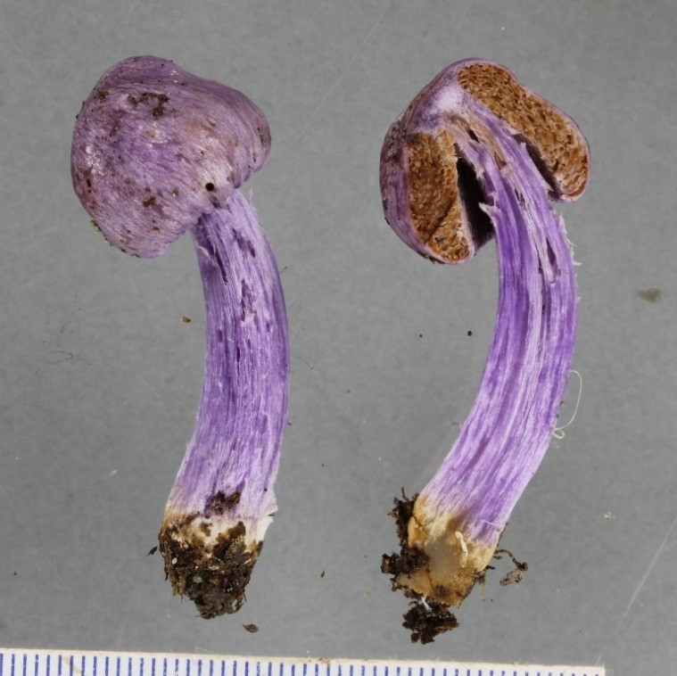

Sporing bodies of one of seven species of purple pouch fungi that occur in New Zealand: the newly described Cortinarius diaphorus. (Image: DA Orlovich and AR Nilsen, reproduced with permission).

Note that past Fungi Portraits are now available on the AMS website. Thanks to Tom May for providing our Fungi Portrait articles.

Regards

Leona

